AnnieMac Worx
Absentee Owner Listing System

- MLS Tax Roll Course or Helpline from your local Board of Real Estate to acquire a list of Property Owners whose Property Tax Billing Address DOES NOT MATCH the local property address. Aim for 1000 Absentee Owners.
- Acquire Folding Note Cards, Envelopes and Stamps 1000 Units.
- Use Outlook or Google Calendar to schedule 2 hours each week for 20 Notes Per Week
  - If you have the money hire someone at $10-12 per hour to provide you 20 per week
  - Always have employee show you the finished product before it is mailed

- 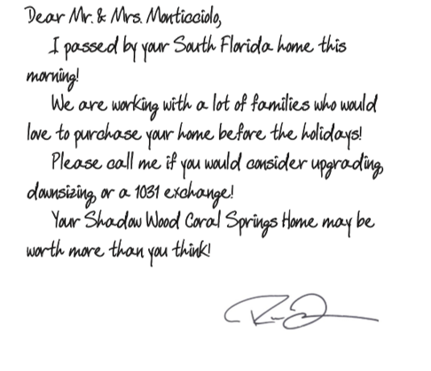 or 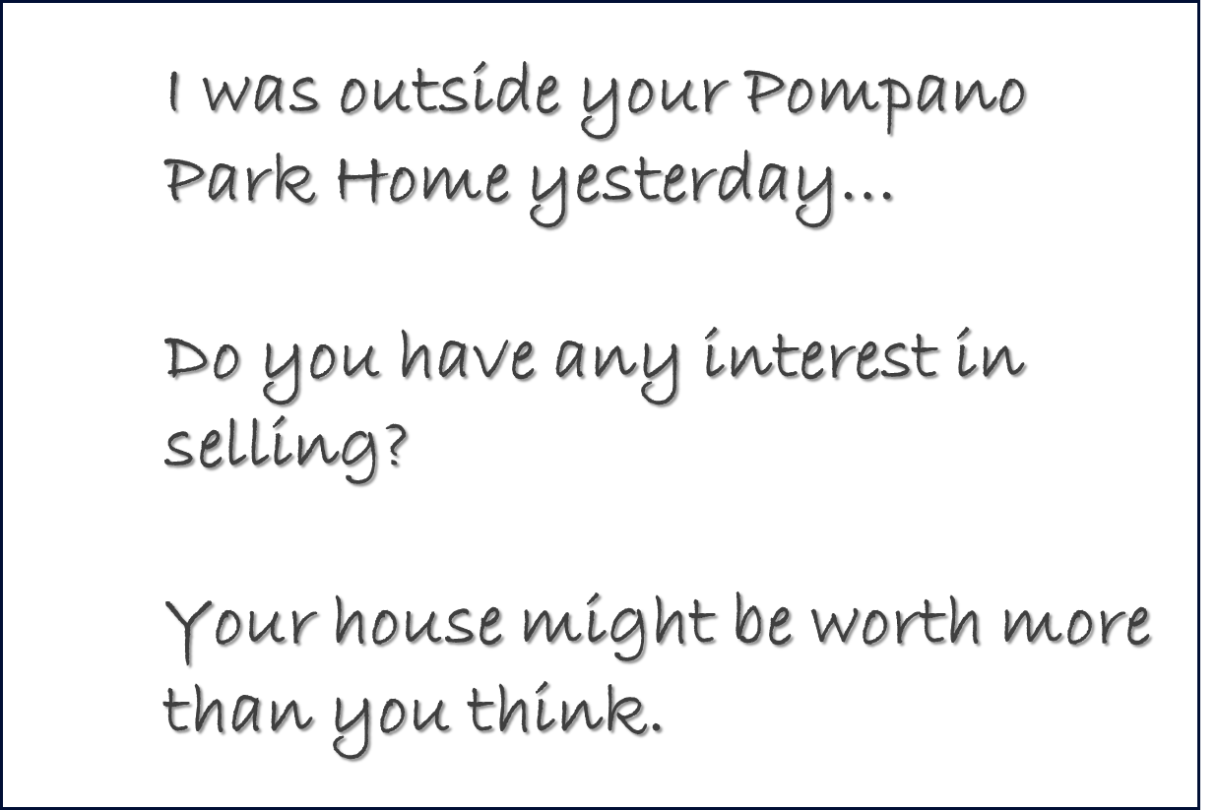
- Use Subdivision Name in the handwritten Note whenever possible and include business card.
- Remember hand addresses envelope and NON-SPECIFIC Return Address IE. No company Name
- We recommend a regular recurring pace of 20 per week rather than 1000 in one mailer. The pace is important to manage inquiries, follow up, CMAs, Appts.1-2 inquiries per 20 mailed is avg.
- Expect dry spells and boom spells throughout a calendar year. The important thing about any system is repetitious involvement over time. 20 per week x 50 weeks is our recommended flow. We have seen as few as 30 inquiries per 1000 over a calendar year and as many as 170 inquiries for the same number of notes. We believe the variable(s) effecting response rates to be handwriting, business card aesthetics, company reputation or brand and market conditions.
  - In a low interest rate market or during periods where appreciation has been high for a sustained period, sellers may be more inclined to liquidate absentee owned Real Estate. LIKE RIGHT NOW
- Answer your phone! Answer your phone professionally and with courtesy. This is very important for the success of the program. Consumers rarely leave voice mail messages on initial inquiry.
- Introduction!!! Thanks for calling, try to sound busy and upbeat and professional, see if you can infer something about the pace of the market being heightened and exciting. I.E. It a very interesting time to sell a house in “Coral Springs Florida” right now!!! Selling Real Estate is fun right now with interest rates under 4% and lots of well qualified buyers!!! We have experienced about an 11-year boom in housing values. I guess everyone is waiting for the bottom to drop out because of tariffs or politics but my clients are having good luck selling right now!!! I don’t know what next year (election year) is going to be like, but this year is awesome. If we learned anything from the past, Real Estate is certainly cyclical, and we are on the crest of an upward cycle. Practice one that you feel comfortable with and make it your own!!! Don’t force it make sure you feel natural and you believe what you are saying.
- Opportunity!!! After the introduction and small talk. Can I ask you the million-dollar question? If you were happy with the price, I mean “really happy”, would you at least consider selling this property between now and (pick a date or a holiday or season about 4-6 months in the future). Are you familiar with 1031 Exchange? If we could get you a great price for your ABC XYZ property, would you reinvest through 1031 exchange or just stay liquid for a while. Have you analyzed your equity position on this property? I.E. how much money you stand to make???
- W.I.F.M. This is the key to great SALEMANSHIP!!! After the property owner responds (either positively or negatively) you need to interject a value add. What is in it for him/her???
    - Have you ever worked with a Professional Staging Company when selling Real Estate in the past? Find out how at www.reseworx.com
    - Have you seen our companies Digital Marketing Brochure, we actually build a stand alone website for every house that we market? Digital Marketing Brochures (once built) can be used in Social Media, YouTube and all over the web. I could create a DMB Website for your (subdivision name) home and you would always have it for rentals or if we ever decide to sell. Free Service at www.myworxsuite.com
    - I offer a free service called PRELISTING INSPECTION approx. $400 value to identify equity killers and staging opportunities, our clients love the free report and analysis and it helps them plan for a sale sometime in the future.
    - My accountant is great, and he would be happy to review your capitol gain situation for free. He and I have done lots of work together and you might love the idea of a 1031 exchange.
    - Have you heard of our STORM PREPAREDENESS PROGRAM? Whenever a dangerous weather pattern approaches my company organizes volunteers and vendors to help prepare my listings for the storm. I can put you on the list even though you haven’t listed your home… yet.
    - We run a complete concierge connection her at ABC Realty. I can give you access to our Team and whenever you need roofing, landscape, pool maintenance or other vendors we can coordinate quotes and access through our network.
- O.H.T. Market Timing
  - Start to see the market in terms of what is in it for the seller.
    - Low Interest Rates
      - Seller can buy their next house cheaper
      - More Buyers Qualified and shopping
      - Typically, contribute to a strong Real Estate Market
      - Good time to sell!
    - Election Year Approaching
      - Short Term future risk
      - Market may change
      - Markets typically pause (brace themselves)
      - This year is still good… real good!
    - Low Inventory
      - Simple Supply and Demand still needs to be illustrated and explained as to why the low inventory results in a higher price for sellers
      - Most Homeowners do not watch the inventory levels and have a hard time correlating the lower inventory to a benefit to them. That is your job to illustrate and document the opportunity.
        - Higher Price
        - Faster Sale
        - More Convenience and Peace of Mind
        - Strike while the Iron is Hot
    - Long Cycle of Appreciation
    - Economy
- Call to Action The ultimate closing question is a terrific “If I could” backed up by an easy convenient “would you”. This is great Salesmanship 101
  - “If I could” put together a full evaluation and do some math “would you” be available this weekend to get on a call with me????
  - “If I could” show you how much money you stand to make on the sale “would you” allow me to do a prelisting Inspection?
  - “If I could” sell your house and close by (certain date 4 months out) “would you” be willing to look at the math with me???
  - “If I could” find your current tenant a new home and they agreed to move out this (season) “would you” be inclined to take a closer look at selling sooner? Interest rates are so low, and I have Down Payment Assistance Programs to help them relocate.
    - You need to find your own sales style but don’t wing it. Professional Sales is about being equipped with a quantifiable best way to say something so that it has the highest probability of positive response.
- Preparation CMA Go to your board of Realty take CMA class, consider taking a Real Estate Appraisal course to enhance your resume, credibility and confidence. Don’t forget to search properties that they might like to own, beach, lake, golf. Show them properties that bring a higher ROI, maybe a perfect Airbnb project that they can earn more revenue but still enjoy vacation usage?? Be Creative and Brainstorm ideas about what to do with the money??? Being Liquid is not a bad thing, ETFs like QQQ, SPY, mutual funds, stock market or helping a child buy their first home al might resonate with the typical Absentee Owner.
- Listing Presentation Visit www.AnnieMacWorx.com and find the Bullet Proof Listing Presentation Training module in our 24/7 OnDemand Library or Ask your AnnieMac Mortgage Professionals to coordinate a Lunch & Learn at your office.
How Much Would 4 Listings Make you in Gross Commission Income? ____________________________
How Many Buyers would you meet off the 4 listing signs, open houses, Digital Marketing? ___________
How much would you make off the buyers? ___ How much if one of the 4 Sellers bought from you? ___

Write in the space below: I will list 4 Absentee Owners this year, thanks AnnieMac!!!

